**Requirements**

The RUM Event Hub shall provide associations with a platform to promote their activities as well as an easy to use interface for students and university personnel to find relevant events on campus.

**User Stories**

1. As an unregistered user, I want to visit the app main page and learn about what the app can do.
2. As an unregistered user, I want to create a new account either as a regular user or as an association.
3. As a registered user, I want to login with my credentials.
4. As an unregistered user, I want to search for specific events based on categories.
5. As a user with an association account, upong login I will be led to a dashboard for the association where I want to see the list of upcoming events with their details.
6. As a user with an association account, from the dashboard I want to edit, delete or add an event to the association’s calendar.
7. As a registered user, I want to “ping” the events I am interested in.
8. As a user, I want to give feedback to the event coordinator.

**Personas**



*Luis Pomales (student)*

Luis Pomales, aged twenty, went to a public high school in the metropolitan area of Puerto Rico. He always had an inclination towards technology, and in his senior year of high school he settled on pursuing a computer engineering degree at the University of Puerto Rico-Mayaguez. Currently, he is a second year student that is actively involved in the community. His interests include: coding, video games, soccer and hanging out with friends to play ping-pong at the university grounds. Sometimes he gets involved in activities like workshops, sales and other student/professor led events too. In the future, he dreams of working in a large tech company, such as Google, Microsoft, Tesla and SpaceX. For this, he’s gotten involved in various seminars from visiting companies and tried his luck at a couple interviews as well. Unfortunately, he hasn’t attained much knowledge in and out of his degree to allow him to answer the questions on his interviews, but he takes that as motivation to continually practice and get better overall.

He likes to study and work hard, but occasionally he has trouble getting centered on his homework and the tasks he has at hand. Mostly because he has a busy schedule filled with different university activities, classes and hobbies that he tries to manage daily. However, from an early age, his parents consistently reminded him of the importance of self discipline and responsibility; because of it he tries really hard to make his parents proud. It’s rarely the case he derails and hits some bumpy obstacles, but when he does he eventually pulls himself together to carry on.



*Andrea Garcia (student / organizer)*

Andrea is a senior student at University of Puerto Rico, mayaguez campus. She studies marketing which she has always been great at. Since she was little, she has been designing and selling jewelry which she continues to do as a side job. By pursuing this degree, she hopes to keep learning the proper methods of turning her little business into a real profit. Andrea’s first year of college was not easy at all. She was almost kicked out the first year for flunking half of her classes because she considered hanging out a priority over going to the midterms. Since that first year, she has taken some time managing courses and developed healthy habits to plan her time in the best way possible. She is currently the president of ACAF (Photography Association) and takes her role very seriously. She plans weekly workshops to the open public and because of this, has found a new passion for teaching.



Alfredo Rivera (student)

Alfredo Rivera is a first year biology student at University of Puerto Rico, Mayaguez campus. Alfredo is 18 years old, and eager to meet fellow students. He enjoys hanging out with friends inside and outside of campus whenever he can get a little break from studying. He comes from Caguas, where he lived all his life before moving to a small apartment near campus. Since he stays close by, he walks everyday to campus and tries to arrive before any of his classmates. As soon as he graduates from his bachelor’s degree, he plans on leaving the island to study medicine in St. Kitts where his uncle is a teacher. By studying medicine, he hopes to travel as a medical volunteer. To accomplish his high goals, he knows he has to start building a good portfolio, and that is why he gets involved in every association and investigation he sees. He is currently set to become secretary of the PLU Association for next semester.

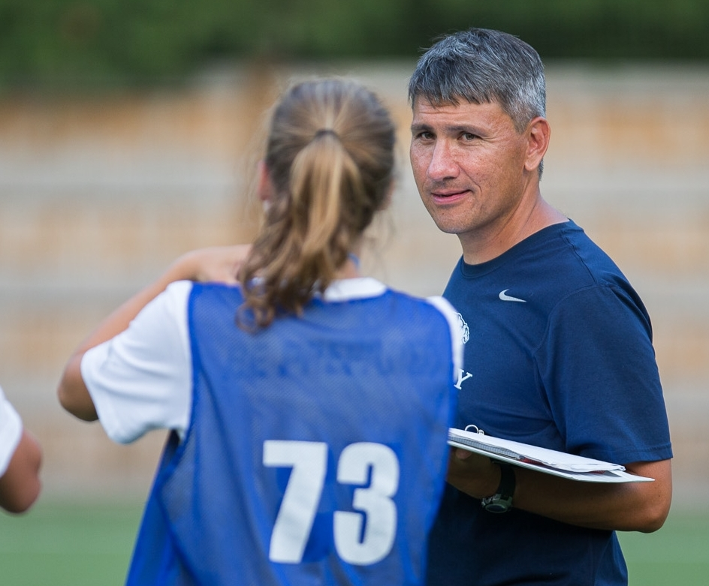

*Javier Molina*

Javier Molina is a soccer team coach at University of Puerto Rico - Mayaguez. He is originally from Argentina and has coached many teams throughout Latin America. He started out as a youth soccer player and eventually switched to management after a severe injury. His career started as an interim manager for hometown side Club Atlético Alumni, and later on was hired to manage national teams. After he got married with a Puerto Rican woman, he moved to Puerto Rico where he has lived for the last 5 years. He is super passionate for the sport and has always loved to have the stadium full of people watching his teams play. In his free time, he becomes one of the fans on the seats cheering for the players and is always inviting his friends to watch the games.

**Use Case Diagram**

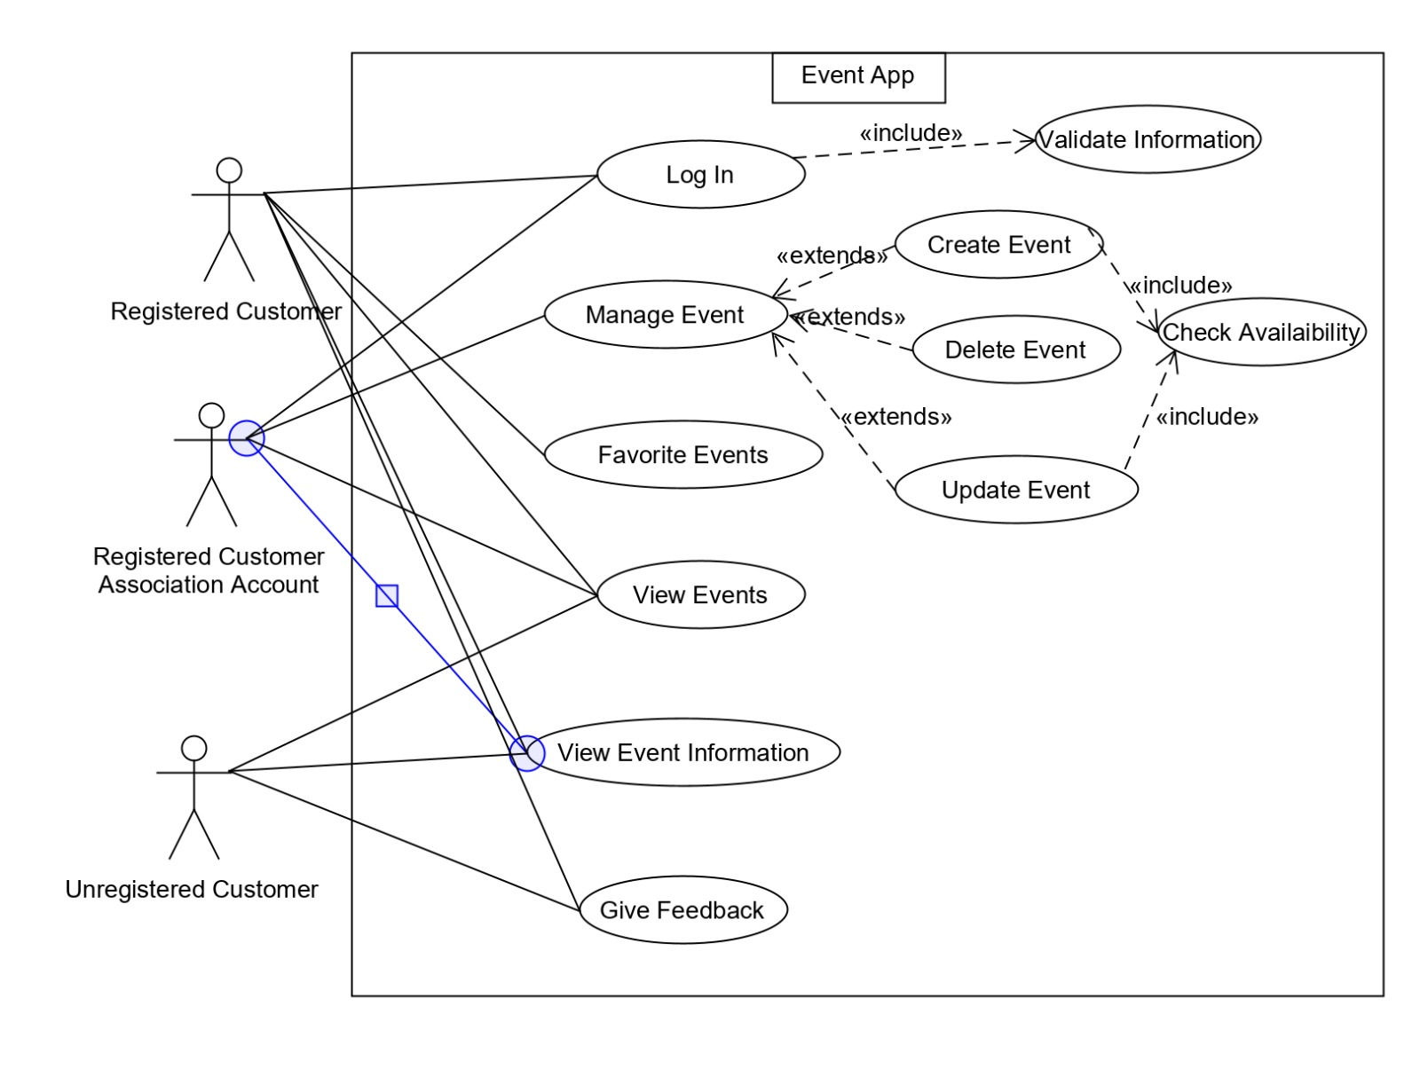

**Progress (Images of the website)**

* Main Page Snapshot

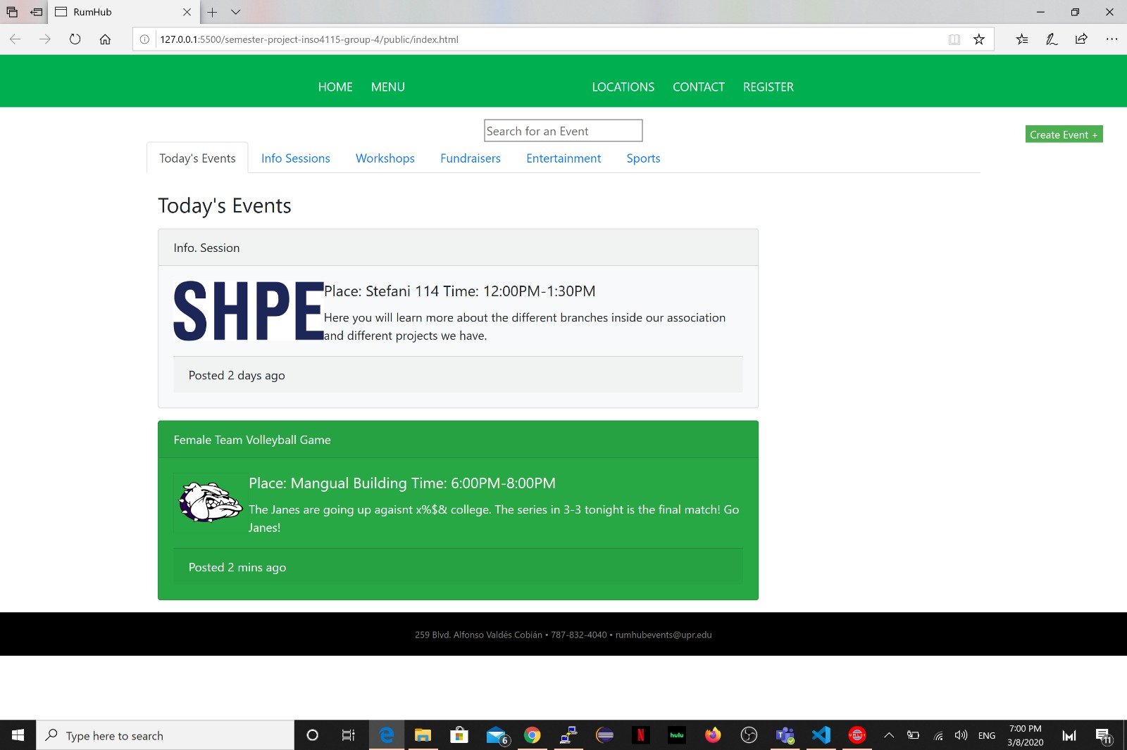

* Event Form Snapshot

